**AIR UNIVERSITY**

**IBRAHIM SAQIB**

**232526**

**BSCS(C) EVENING 2023**

**PHASE 01 OF CREATING A WEBSITE USING FIGMA AND GITHUB**

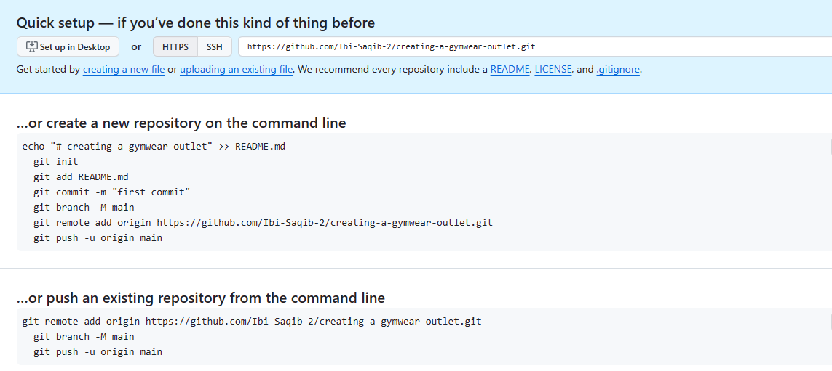

LINK OF GITHUB ACCOUNT:

<https://github.com/Ibi-Saqib-2/creating-a-gymwear-outlet.git>

FIGMA USAGE:

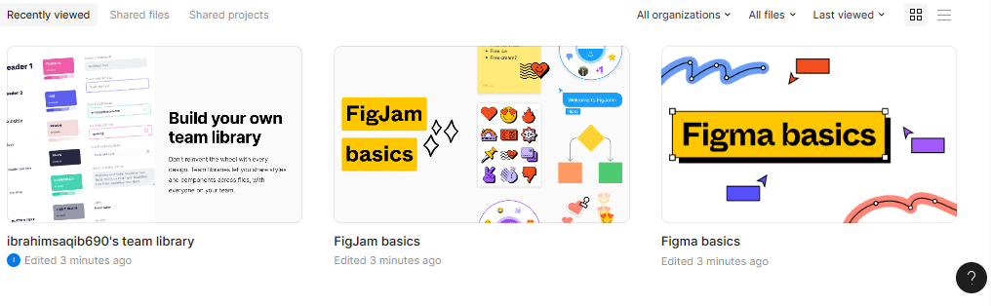

FIGMA BASIC WEBSITE GENERATION:

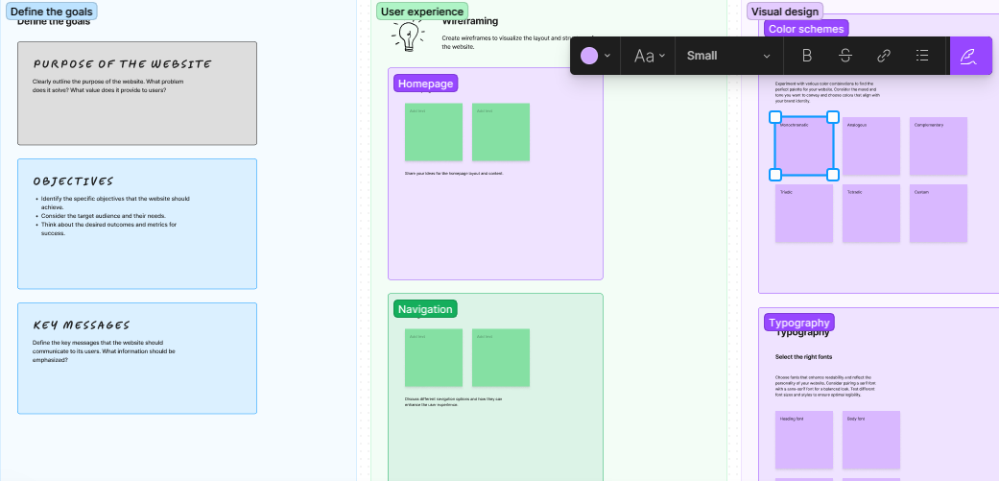

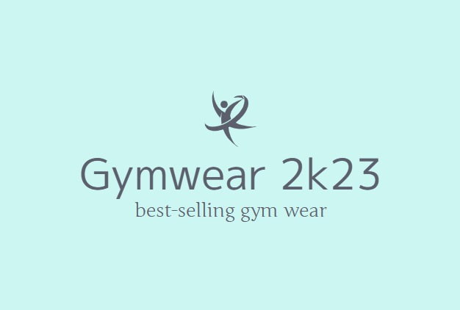

**ABOUT US:**

We are the most newest brand in town here to surprise you with all our amazing line of clothing for youn to wear when working out. We are not like the others. We test our gymwear to see the size and quality before delivering to our customer. Buy from us you shall be amazed by our equipment. Shop now!!!!!

**CONTACT US:**

[Abc@gmail.com](mailto:Abc@gmail.com)

03*********

LINK TO FIGMA ACCOUNT:

[Recents and Sharing – Figma](https://www.figma.com/files/recents-and-sharing/recently-viewed?fuid=1312452391854667993)

I WILL BE CREATING AN ONLINE GYMWEAR STORE IN WHIC I SHALL SELL GYM CLOTHING AND ESSENTIALS FOLLOWING IS THE FIRST PHASE:

**Planning**

Name: GYMWEAR 2023

Purpose: To showcase my skills and experience to potential employers or clients. And to boost sales and generate revenue.

Target audience: Potential employers, clients, and other professionals in my field.

**Content:**

* Home page:
* Brief overview of me and my skills
* Portfolio of my best work
* Contact information
* About page:
* More detailed information about me
* My skills and experience
* My education and training
* Portfolio page:
* A curated selection of my best work
* Brief descriptions of each project
* Links to live projects
* Contact page:
* My email address and phone number
* A contact form
* Links to my social media profiles

**Design:**

* Clean and modern design
* Easy to navigate
* Responsive design that looks good on all devices

**Technology:**

* Figma for design
* HTML and CSS for development

**Timeline:**

* Design the website in Figma
* Develop the website in HTML and CSS
* Test and deploy the website

**Tools:**

* Figma
* Code editor
* Web browser

**Budget:**

* $0 (I will be developing the website myself)

**Process:**

1. Design the website in Figma. I will start by creating a wireframe of the website to get a general idea of the layout. Then, I will create high-fidelity mockups of each page of the website.
2. Develop the website in HTML and CSS. Once I am happy with the design of the website, I will start developing it in HTML and CSS. I will use a responsive design approach to ensure that the website looks good on all devices.
3. Test and deploy the website. Once the website is developed, I will test it thoroughly in different browsers to make sure that it works as expected. Then, I will deploy the website to a hosting service.

**Evaluation:**

I will evaluate the success of the website by tracking the following metrics:

* Website traffic
* Time on site
* Bounce rate
* Lead generation

I will use this data to make improvements to the website as needed.

**Additional Considerations:**

* Search engine optimization (SEO)
* Accessibility
* Cross-browser compatibility

I will make sure that the website is optimized for search engines, is accessible to all users, and works in all major browsers.

**Resources:**

* Figma
* HTML and CSS tutorials
* Web accessibility guidelines

I will use these resources to help me create a website that is well-designed, developed, and accessible.

PHASE 2 AND 3 SHALL BE UPDATED WITH THE GIVEN TIME